Institutional Factors and Marketing
First published in 1991 The Big Issue has gone from strength to strength to become the world’s most widely circulated street newspaper. It officially belongs to the hybrid genre of entertainment and social business and as such, runs regular reviews on films, book releases, theatre, music and art but no television listings – the entertainment aspect attracts advertising revenue while the editorial content is often critical of big business, banking and commerce and champions the political cause and role of the individual within society. David v Goliath narratives are common as downtrodden groups and disparate individuals fight corporate giants but the magazine has come under some criticism for its ‘flashy style’ as a street newspaper and as being overly commercial.
When John Bird and Gordon Roddick founded the magazine their aim was to offer homeless people, or people at risk of homelessness the opportunity to earn a legitimate income by selling the magazine – the cost of the magazine is £2-50 with £1-25 going to the trader. This was the primary objective of the magazine as an independent publication to offer a public service and to try and improve a social problem which they saw as endemic – John Bird MBE remains the Editor-in-Chief and still writes a regular column at the back of the magazine. Recently (January 2013) he appeared on BBC1’s discussion panel show Question Time surprising some viewers with his admission that he is a ‘working class Tory’. Other writers in the magazine Bird works with include professional journalists and new and established writers.
Bird’s own background was pivotal to launching The Big Issue – he was homeless at the age of 5, residing in an orphanage between 7 and 10 and had a spell in prison as a teenager. After leaving prison he slept rough on the streets of London before returning to prison in his late 20s. Four years after founding the magazine in 1995 he launched The Big Issue Foundation, a registered charity to further help the homeless. The Foundation provides magazine vendors with information, advice, guidance and support on a range of issues.
As an independent publication (published by The Big Issue Company Ltd.) it needed, and received £25,000 start up capital, donated by The Body Shop (the founder of the Body Shop, Anita Roddick was the wife of co Big Issue founder Gordon Roddick). At its peak The Big Issue sold 300,000 copies in 2001 but as sales declined over the decade (along with the circulation of all print media) it re-launched with a new look and new columnists including controversial Premier League footballer Joey Barton. Weekly circulation (every Monday) has improved to around 58,000 and presently there are 6000 registered sellers all over the UK with acknowledgement that there are also rogue traders (without large red jackets and clear id badges) who have ‘acquired’ copies of the magazine illegally. Most of the vendors conform to the male (85%) homeless stereotype, are 18-46 with broken relationships and subsequent problems given and the major reason for their homelessness
Audience Appeals
Undoubtedly there is an element of emotional fulfilment in buying a copy of The Big Issue – this feel good factor associated with charity giving has to be identified as one of the key appeals of the magazine. In making a purchase you may feel better ideologically knowing you are helping rough sleepers and the homeless. This is why ‘carers’ using psychographic research are targeted by the magazine. Using a different model of audience, the Uses and Gratifications model Surveillance very much applies as one of audience pleasures gained from reading the magazine. Information is available on socio political issues but also the entertainment aspect in that you can read about a current issue but then indulge in reviews and analysis of culture.
The target audience of The Big Issue also enjoy the fact that it speaks to them, in terms of modes of address ‘in their own language’ using an elaborated language code assuming a level of intelligence and cultural capital. This balanced approach cloaks up to a point any encoded ideology and massages carefully the readers’ understanding of key issues. Articles and stories assume some prior knowledge e.g. in the edition October 8th 2012 a piece on the American Presidential Debate required some knowledge of the American constitution and political history. Shared ideological beliefs is also a key appeal for the audience as notions of personal relationships apply – in the same edition an ironic advert for ‘Dick Sapphire’ lectures on how to make money targets the audience’s left wing, liberal leanings as they are aware the lectures are written and performed by comedian Rory Bremner, known for his strong political opinions on issues ranging from Health Care to Education and Politics. These are all areas audiences would expect The Big Issue to cover.
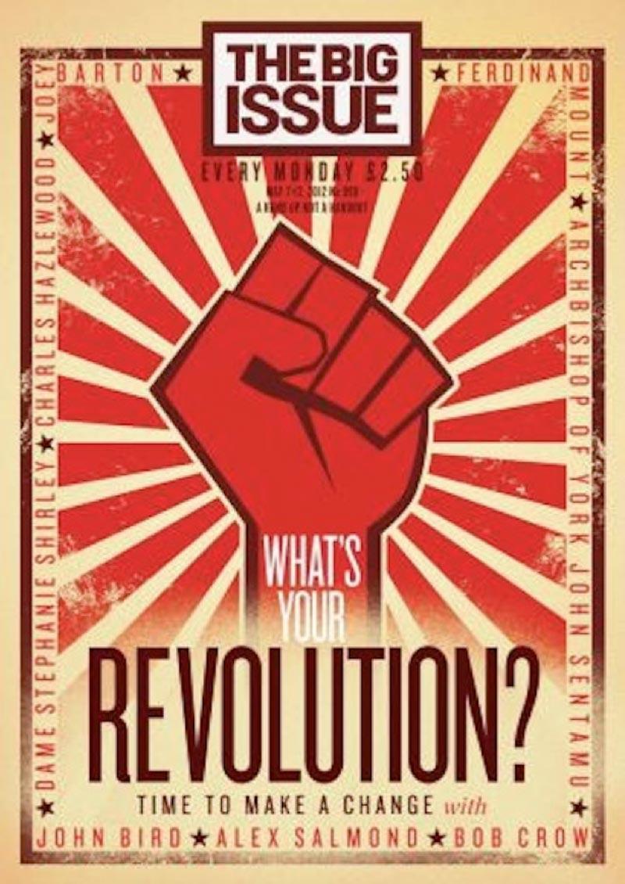
The reader is made to feel ‘independent’ by the reactionary, sometimes controversial approach the magazine has, against dominant mainstream culture. Even the adverts do not follow mainstream conventions with copy including National Book Tokens, ‘Let’s Trek for Children’ and Safer Medicines. There is an element of the alternative here with the caring, liberal audience appreciating the lack of adverts for high street brands whose primary objective is commercial gain. Along with this, even the celebrities found within the magazine are associated with more realist human interest stories while at the same time remaining aspirational as figures the target audience can identify with and relate to. The central story, “What’s your Revolution?” is a rhetorical question challenging the target audience making clear linking to the Communist Russian Revolution – this is an attempt by the magazine to return to left wing political values.
- The connotations of the Russian Revolution are evidenced by intertextual reference to Constructivist art which references the cultural capital of an ABC1 demographic – the fist, stars and design are common to this art movement.
- “Time to make a change” has a double meaning by referencing a need for political change but also by referring directly to new writers – Alex Salmond as leader of the SNP has obvious credentials to write for a politically motivated magazine, Bob Crow is the reactionary, left wing General Secretary of the RMT known for bringing railway workers out on strike while the Archbishop of York is an outspoken block cleric on issues of multiculturalism and homosexuality. The controversial Premier League footballer Joey Barton is included as a controversial figure who has been subject to considerable criticism and media speculation.
- Dame Stephanie Shirley is the only female writer on the front cover which anchors the male dominated narratives and viewpoints contained within the magazine – Dame ‘Steve’ Shirley (adopting the name Steve to help her in the male dominated business world) is a businesswoman and philanthropist whose work has focussed on creating work opportunities for women with dependents.
Genre
- As a hybrid magazine of entertainment and social business key entertainment conventions include reviews on television, film, book releases, theatre, music, the arts (see some display adverts). As identified before these entertainment aspects draw in advertising revenue as this is one of the key appeals of the magazine (see above). Front covers are nearly always entertainment based with frequent use of celebrity to anchor a narrative – see front page deconstruction below. The Big Issue remains an unusual hybrid as entertainment magazines are rarely hybridised with social business and as such this positions the magazine as having a USP.
- In terms of social business, the magazine runs so called ‘serious stories’ – social issues e.g. AIDS in Africa, Wikileaks, liberal politics, ‘David and Goliath’ stories which commonly focus on individuals and their struggle against corporations in classic binary opposition. Definitions of social business are businesses that are associated with working for the benefit of the people e.g. Charities, Education, Healthcare, Housing…This is clearly identifiable as a key convention of The Big Issue as it places this as an ideological imperative. Businesses foregrounded often associated with a more caring approach include Virgin, Innocent Smoothie, Co-op Bank, Organic Milk, National Book Tokens, Skillset and the University of the Arts. Critical of big business, banking and commerce the articles are often anti-government, state control and use of power. Despite the unusual hybrid The Big Issue retains some of its generic features including regular articles at the back of the magazine by John Bird and a guarantee of a ‘big splash’, colour cover that is challenging and provoking.
Representation
- Pluralistic representations reflect the fact that the magazine is independent – it offers a diverse range of representations but a key focus on minority groups e.g. the homeless which positions it as a media text that like The Guardian, foregrounds narratives about minority groups. Connotations of being politically liberal and socially aware and against mainstream representations are written into the magazine despite the prior admission as identified earlier of John Bird’s Conservative political sympathies. The Big Issue wants however to be seem as the antithesis of right wing political ideology and this is evident from front covers and content analysis.
- In relation to gender the magazine has a male dominated narrative despite the alleged 59% readership (according to The Big Issue). I personally rarely see the magazine purchased by female consumers and the content seems to stereotypically target ‘male issues’. This is a problem for The Big Issue as it wants to appeal to both genders. The magazine is sold not exclusively but commonly by male vendors and homelessness in terms of statistics is a ‘male problem’. As difficult as these statistics are to interpret there are many, many more homeless males in the UK than female and as a result ABC1, educated male consumers are more likely to be aware of this.
- Representations of Age is interesting - The Big Issue allegedly has a younger target audience according to the magazine’s own demographic analysis but many articles suggest a need for cultural capital associated with an older demographic e.g. one article on William Shatner as James T Kirk would present ‘problems’ for a younger reader. In this regard however statistics indicate that homeless people in the UK are more under 45 than over 45 with a significant percentage under 35. Representation of art and culture are preferred to mainstream entertainment which again would stereotypically attract an older audience with a positive focus on representations of working class culture despite the middle class readership.
- Compared to any genre of magazine The Big Issue has low production values but compared to most other so called Street Magazines has higher production values. Again, as with most magazines The Big Issue is sustained by advertising revenue and by The Big Issue Foundation and supported by www.bigissue.com. The cover is often flamboyant, revealing a high level of cultural and political awareness (see above covers which use intertextual links to an Alfred Hitchcock film to link to budget cuts and debate on the power of television) but also understanding the cover is the main point of sale. The Big Issue is sold (points of distribution) in city centres, built up urban areas, train stations and shopping centres with the bulk in London where there is a high percentage of Romanian vendors. The magazine, although dealing with national issues is up to a point globally published being available in Australia, Japan, South Africa, South Korea, Namibia, Kenya, Taiwan and Malawi where content is bespoke to country and culture.

